Khurrm Shahzad

Khurram Shahzad
Title: File Integrity Monitoring System -

1. Introduction
In today's digital era, protecting data from unauthorized access and unintended modifications is crucial. A File Integrity Monitoring (FIM) system is a security solution that checks and monitors files for changes that might indicate a cyberattack or internal misuse. This report details the design and implementation of a Python-based File Integrity Monitoring System with advanced features including real-time monitoring, automatic backups, hash verification, and a graphical user interface (GUI).

2. Objectives
- Detect and alert any unauthorized file modifications.
- Provide real-time monitoring and reporting.
- Automate backup of changed files.
- Generate and compare hash values for integrity verification.
- Provide a secure, user-friendly GUI.

3. Tools & Technologies
- Language: Python 3.x
- Libraries: hashlib, smtplib, watchdog, tkinter, pandas, openpyxl
- Platform: Windows 10
- IDE: VS Code / PyCharm

4. System Features
- Initial Full Scan: Computes and stores hash values of all files.
- Re-scan & Comparison: Verifies if files are unchanged or tampered.
- Email Alerts: Sends alerts if file changes are detected.
- Real-Time Monitoring: Uses watchdog to monitor changes live.
- Export Report to Excel: All scan data exported to Excel file.
- Dark Mode GUI: Modern dark-themed UI for ease of use.
- Password Protection: GUI secured with login credentials.
- Exclude Specific Files/Folders: Configurable to skip selected paths.
- Auto Backup: Changed files are backed up with timestamps.

5. System Architecture
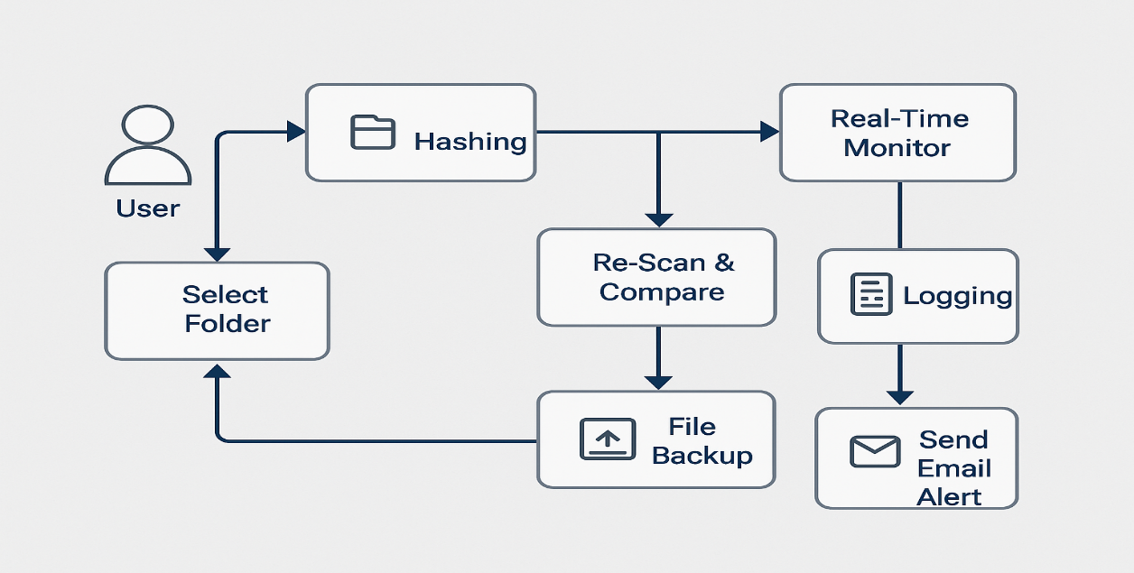

6. Data Flow Diagram (DFD)
Level 0 and Level 1 Data Flow Diagrams are shown below:
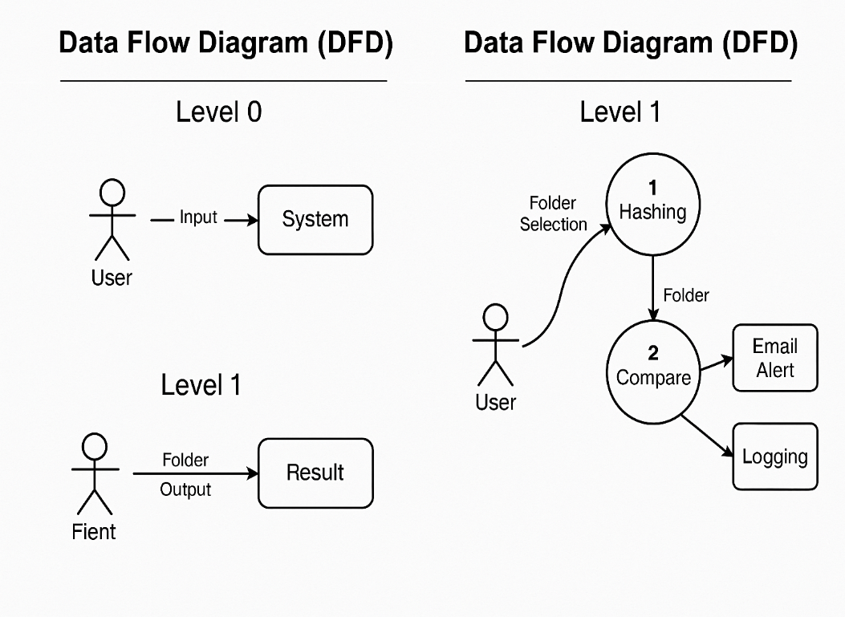

7. Use Case Description
This section describes how different users interact with the File Integrity Monitoring System. The primary actor is the "System User," who can initiate scans, configure settings, and respond to alerts.
- Actor: System User
- Use Case 1: Start Initial Scan
  - Description: The user selects a folder and initiates a scan to generate initial hash values.
- Use Case 2: Perform Re-scan
  - Description: The user triggers a new scan to check for file modifications.
- Use Case 3: Monitor Real-Time Changes
  - Description: The system continuously watches for file modifications using Watchdog.
- Use Case 4: Receive Email Alerts
  - Description: If changes are detected, the system sends an email alert.
- Use Case 5: Backup Modified Files
  - Description: Modified files are automatically backed up.
- Use Case 6: Export Report
  - Description: The user can export results to an Excel file.
- Use Case 7: Access GUI
  - Description: The user logs into the GUI using password protection and configures options.
Visual representation of actors and interactions with the system: 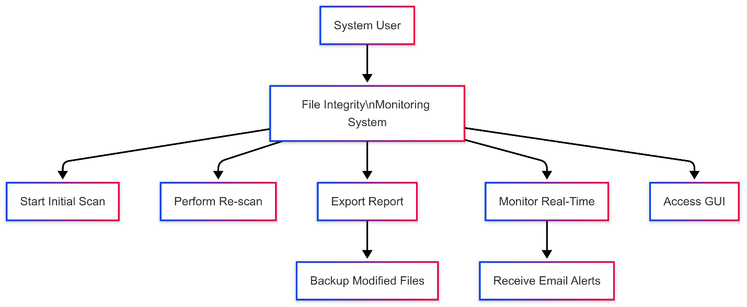

8. Component Diagram
Depicts various components and their interactions:
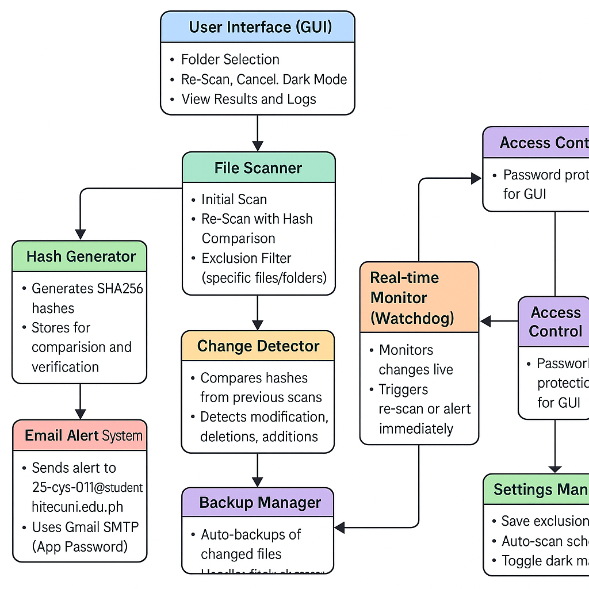

9. Working Process (Enhanced)
This section explains the entire workflow of the File Integrity Monitoring System in a step-by-step manner along with its internal components and user interaction.

zip file FileintergityMonitor_fullPAckage
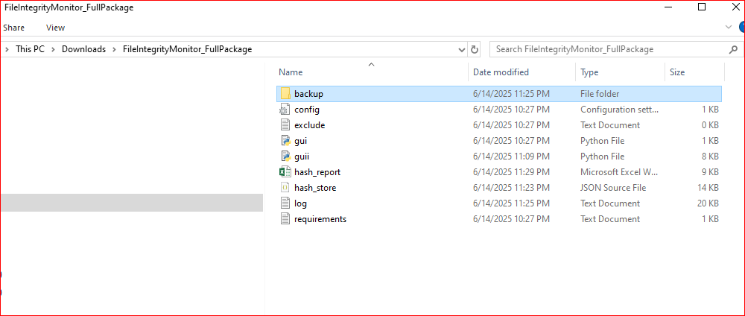

Step 1: GUI Launch and Folder Selection
- The user opens the File Integrity Monitor application using the GUI interface.
- A secure login prompt appears (if password-protected GUI is enabled).
- After login, the user clicks “Browse” to select the directory they want to monitor.
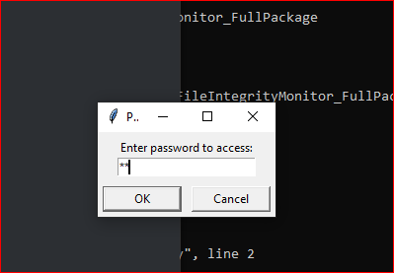
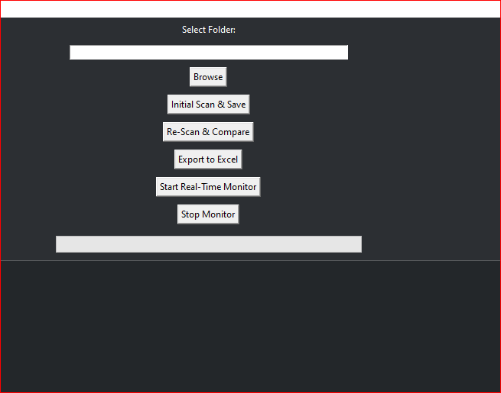

Step 2: Initial Hash Generation (Full Scan)
- The system scans all files in the selected directory.
- For each file, the system computes a SHA-256 hash.
- All file paths and their hashes are saved in a reference table (CSV or memory).
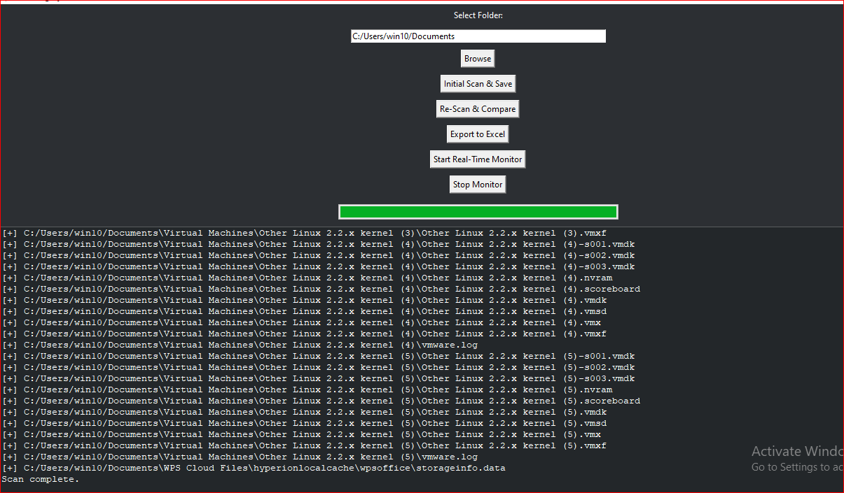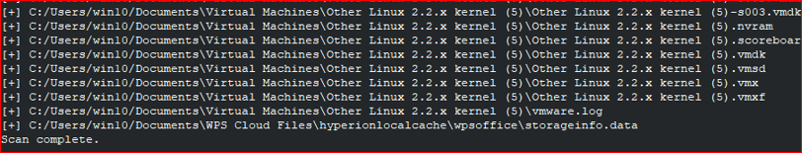

Step 3: Real-Time Monitoring (Watchdog)
- The Watchdog library actively listens for changes like:
  - File modification
  - New file creation
  - Deletion or renaming of files
- This runs in the background continuously.
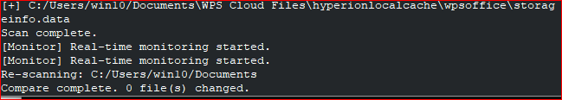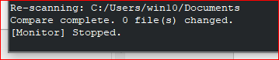

Step 4: File Change Detection and Backup
- If any file is changed:
  - The system recalculates its hash.
  - Compares with the original hash.
  - If it differs:
    - It triggers a file backup in a separate timestamped folder.
    - Logs the event with time and file details.
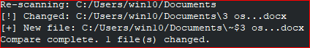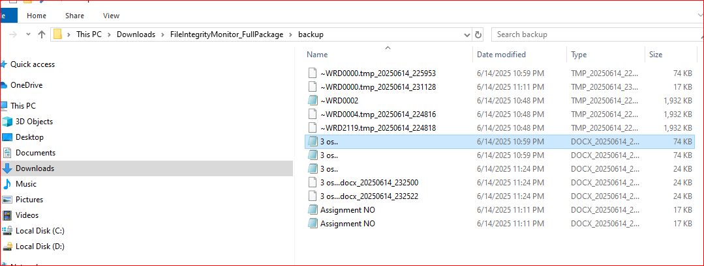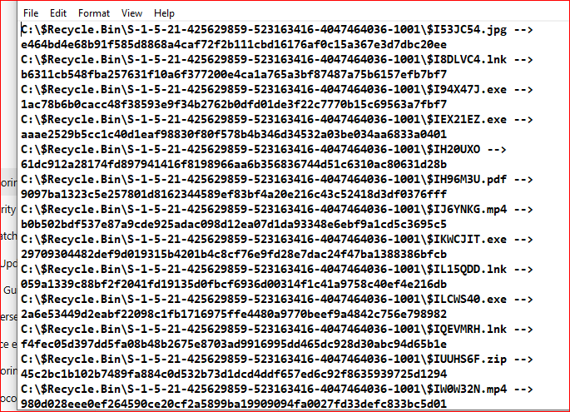
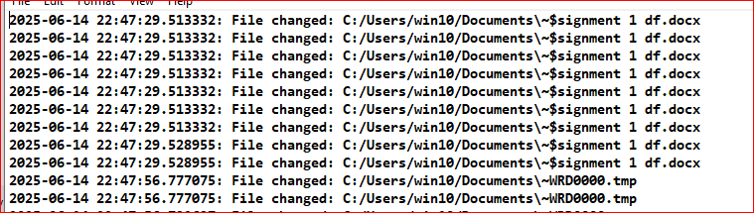

Step 5: Email Notification
- Once a change is confirmed:
  - The system sends an email alert to the configured Gmail account.
  - The alert contains the file name, timestamp, and change details.
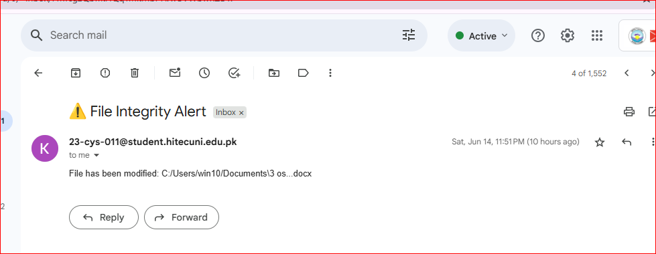

Step 6: Export Report to Excel
- At any point, the user can click “Export Report”.
- A clean Excel (.xlsx) file is generated.
- It includes:
  - File names
  - Previous hash
  - New hash
  - Status (Changed/Unchanged)
  - Backup file path (if applicable)
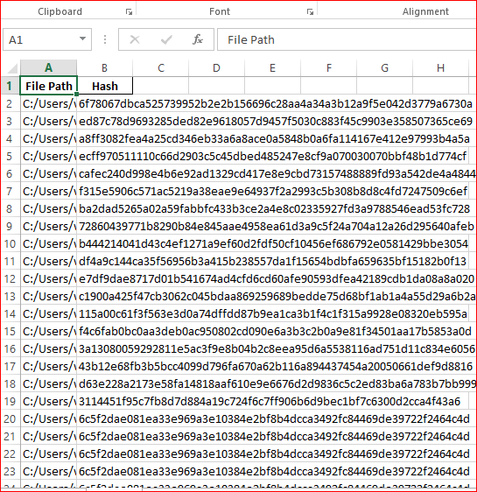

Step 7: Optional Features
- Scheduled Scans: Scans can be scheduled using Task Scheduler (Windows).
- Exclude Files/Folders: User can define paths to skip.
- Dark Mode Toggle: User can switch between light/dark UI.

Step 7: Configuration Settings
- User can configure:
  - Email (Gmail setup)
  - Files/Folders to exclude
  - Scan intervals (for scheduled scan)
- Config data is saved in a .ini, .txt, or .json format.
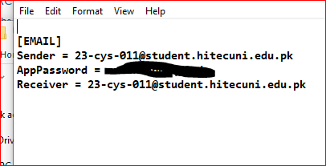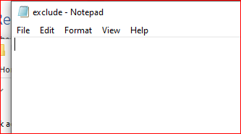

10. Results
- Successful detection of all file changes.
- Email alert tested with Gmail SMTP server.
- Backup files stored in timestamped folders.
- GUI tested with multiple directory paths.
- Exported Excel file confirmed accurate.

11. Challenges Faced
- Handling file lock errors during real-time backup.
- Configuring email alerts using Gmail app passwords.
- Managing large folders with thousands of files.
- Ensuring GUI responsiveness.

12. Future Enhancements
- Add support for Linux/Mac systems.
- Upload reports to cloud storage.
- Integration with SIEM tools.
- Enable role-based access in GUI.

13. Conclusion
The File Integrity Monitoring System was successfully designed and implemented with both core and advanced features. It ensures security, usability, and automation, helping users maintain data integrity and identify suspicious activities in real-time.

14. References
- Python Docs: https://docs.python.org
- Watchdog Docs: https://python-watchdog.readthedocs.io
- Tkinter Docs: https://docs.python.org/3/library/tkinter.html
- Gmail SMTP: https://support.google.com/mail/

15. Appendix

A. Code Snippets
1. Email Alert Configuration
import configparser
import smtplib
from email.mime.text import MIMEText
from email.mime.multipart import MIMEMultipart

config = configparser.ConfigParser()
config.read('config.ini')
SENDER_EMAIL = config['EMAIL']['Sender']
APP_PASSWORD = config['EMAIL']['AppPassword']
RECEIVER_EMAIL = config['EMAIL']['Receiver']

def send_email_alert(file_path):
try:
subject = "\u26a0 File Integrity Alert"
body = f"File has been modified: {file_path}"

msg = MIMEMultipart()
msg['From'] = SENDER_EMAIL
msg['To'] = RECEIVER_EMAIL
msg['Subject'] = subject
msg.attach(MIMEText(body, 'plain'))

server = smtplib.SMTP('smtp.gmail.com', 587)
server.starttls()
server.login(SENDER_EMAIL, APP_PASSWORD)
server.sendmail(SENDER_EMAIL, RECEIVER_EMAIL, msg.as_string())
server.quit()
except Exception as e:
print(f"[EMAIL ERROR] {e}")

2. Hashing and Backup Functions
import hashlib
import shutil
from datetime import datetime

def generate_file_hash(file_path):
try:
with open(file_path, 'rb') as f:
file_hash = hashlib.sha256()
while chunk := f.read(4096):
file_hash.update(chunk)
return file_hash.hexdigest()
except:
return None

def backup_file(file_path):
try:
if os.path.exists(file_path):
base_name = os.path.basename(file_path)
backup_name = f"{base_name}_{datetime.now().strftime('%Y%m%d_%H%M%S')}"
shutil.copy2(file_path, os.path.join('backup', backup_name))
except Exception as e:
print(f"[BACKUP ERROR] {e}")

3. Logging and Excel Export
from datetime import datetime
import pandas as pd

LOG_FILE = 'log.txt'

def log_event(message):
with open(LOG_FILE, 'a') as f:
f.write(f"{datetime.now()}: {message}\n")

def export_to_excel(data):
df = pd.DataFrame(list(data.items()), columns=['File Path', 'Hash'])
df.to_excel('hash_report.xlsx', index=False)

4. Real-time Monitoring Using Watchdog
from watchdog.observers import Observer
from watchdog.events import FileSystemEventHandler

class ChangeHandler(FileSystemEventHandler):
def on_modified(self, event):
if not event.is_directory:
send_email_alert(event.src_path)
backup_file(event.src_path)
log_event(f"File changed: {event.src_path}")

5. GUI Application Using Tkinter
import tkinter as tk
from tkinter import filedialog, messagebox, simpledialog
from tkinter.ttk import Progressbar

class FileIntegrityApp:
def __init__(self, master):
self.master = master
self.master.title("File Integrity Monitor")
self.master.geometry("650x500")
self.master.configure(bg="#2c2f33")

if not self.prompt_password():
self.master.destroy()
return

# Folder selection and buttons
self.folder_path = tk.StringVar()
tk.Label(master, text="Select Folder:", bg="#2c2f33", fg="white").pack(pady=5)
tk.Entry(master, textvariable=self.folder_path, width=60).pack(pady=5)
tk.Button(master, text="Browse", command=self.browse_folder).pack(pady=5)
...

